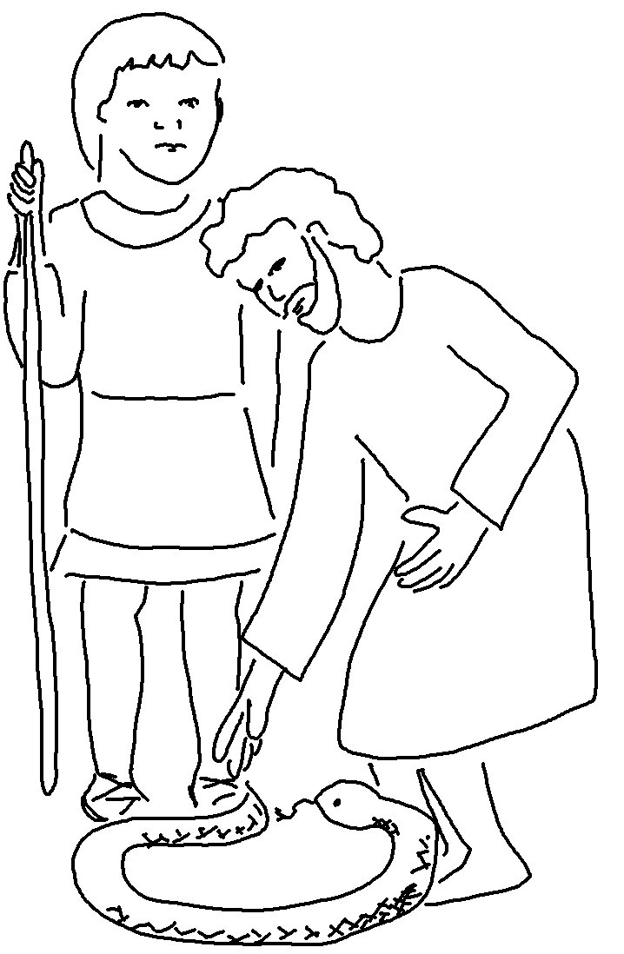
I will help you _ _ _ _ _ and will teach you what to _ _ _. Exodus 4:12_{NIV}

